Name: Shay Walker

Box #613

Professor Sabal

Cairn University School of Business

CIS122 Essentials of Networking

Project #9

Project objective:

Configure a network fail-back solution. Consulting for a company that is in need of a fail-back solution using two or more internet service providers and/or methods.

Equipment used:

(ONLY EQUIPMENT NEEDED TO IMPLIMENT THIS INTO AN EXISITNG NETWORK)

|  |  |  |  |  |
| --- | --- | --- | --- | --- |
| Equipment Description | Vendor | Vendor Item # | Retail price | Actual price (if known) |
| IM7200 Infrastructure Manager | Corporate Armor | IM7208-2-DDC-LR | $3,181.00 | N/A |
| Ethernet Cabling (CAT 5E) | FireFold | CAT5E-1KSOL | $79.99 (1000 ft) | N/A |
| RJ-45 connectors | CableWholesale | 846568016103 | $10.07 (100) | N/A |

Detailed list of software and operating platforms used, including version numbers and licensing requirements: THESE WILL RANGE AND DEPEND ON THE SIZE AND NEEDS OF THE COMPANY.

Verizon Cellular subscription (possible pay as you go since this is the failover plan)

Verizon Fios Connection subscription

Network diagram:

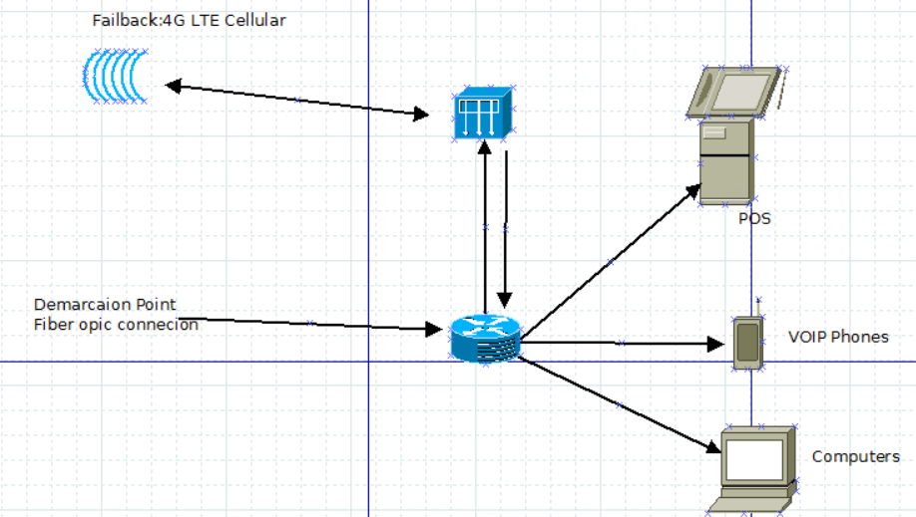

Configurations:

With the company having a fiber optic line which connects to the WAN or LAN through the Demarcation point in the network, which the connects to the router(s) to be spread over the network and be the first internet source. The company would then want to purchase and install an Opengear IM 7200 Infrastructure Manager into their network. This would connect to and from the router and would constantly check the fiber optic lines connection, to make sure that it is functioning properly. The Opengear IM 7200 Infrastructure Manager would then respond if the fiber optic line stopped working and would automatically switch the network over to cellular internet connection and would notify that the fiber optic line was not working and in need of maintenance.

The Opengear IM7200 is a state of the art infrastructure management solution which streamlines remote management of network, server and power infrastructure in data center and remote environments, ensuring business continuity, secure and reliable access.  The next generation IM7200 combines [*Smart* OOB™](https://opengear.com/results/smart-out-of-band-management) out-of-band management with [Failover to Cellular™](https://opengear.com/results/eliminate-network-downtime-with-failover-to-cellular) and delivers proactive monitoring and remediation.

* 8 – 48 port serial console servers. Also available in 16 port + 24 USB 2.0 console ports and 16 port + 24 Gigabit Ethernet Switch
* Dual network connections with built-in Fiber SFP and GbE copper ports
* [Zero Touch Provisioning](https://opengear.com/solutions/zero-touch-provisioning) (ZTP) automation over the network, without manual user interaction
* Link Layer Discovery Protocol (LLDP) discover, identify and verify attached devices on your local network.